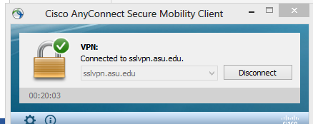

Download Non machine http://www.nomachine.com/download.php.

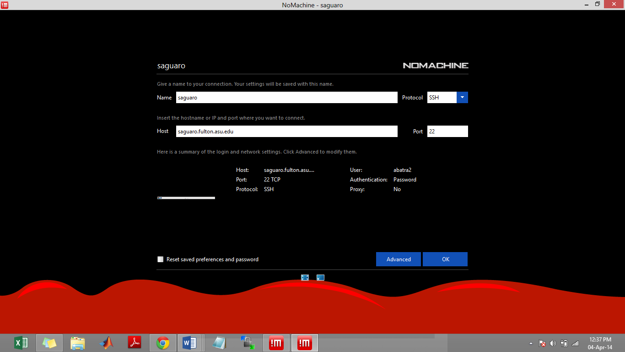
Click advanced
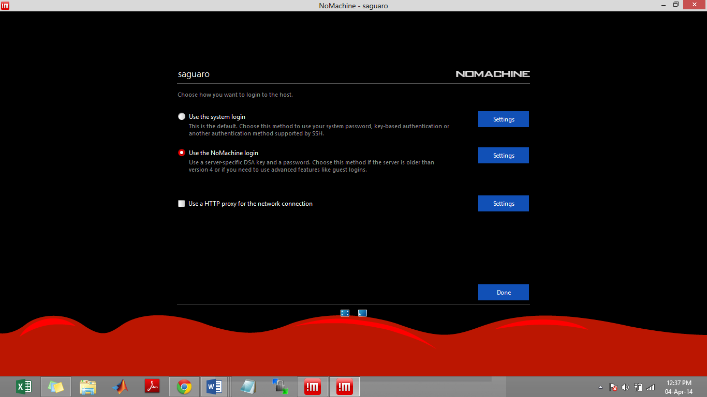

Click connect and thus get connected to saguaro cluster
For accessing the ansys fluent use the following command line on terminal…
qsub -X -I -lnodes=16 -lwalltime=4:00:00
use ansysfluent
use ansysworkbench
fluent

For accessing the ansys workbench use the following command line on terminal…
qsub -X -I -lnodes=16 -lwalltime=4:00:00
module load ansysworkbench/14.5
runwb2

